E FARMING WEBSITE

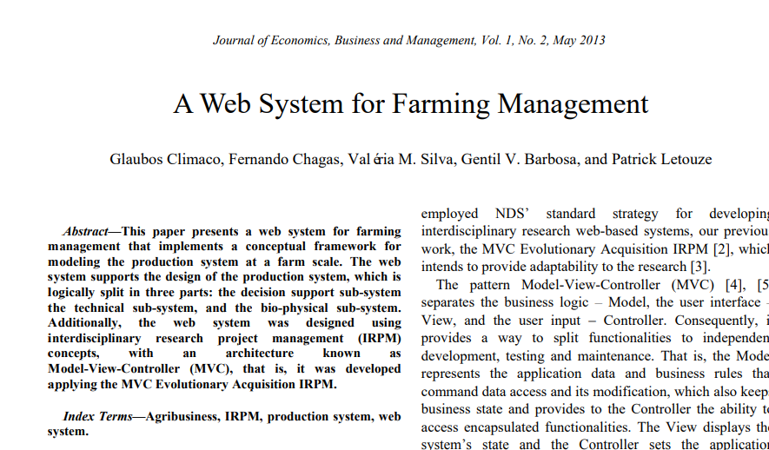

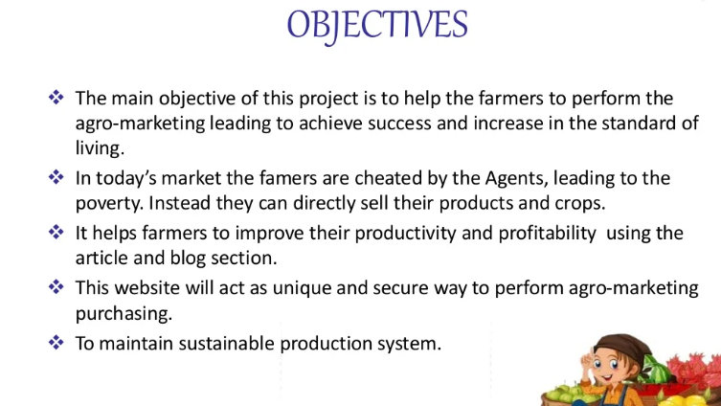

Architecture diagram

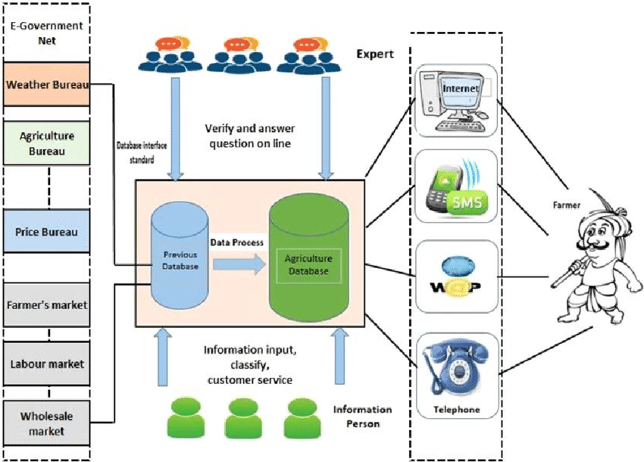

UML DIAGRAM

<https://www.freeprojectz.com/uml-diagram/farm-management-system-uml-diagram>